Slip and Slide: Teaching String Shifting with Ease

Kentucky Music Educators Association

2015 Professional Development Conference

February 7, 2015

Ching-Yi Lin, violin

chingyilin.com

Shifting is generally taught when a student is set-up correctly and familiar with playing in the first position. Below are a few of exercises, games, and pieces that teachers can use to help students successfully navigate around the fingerboard.

VIOLIN: BEGINNING SET UP (PREPARING THE ARM, HAND, AND FRAME):

Sliding on the Magic X
- Violin in rest position or playing position
- A “Magic X” should be marked on the base joint of the student’s left index finger with a pen

Tap over High Dot
- A “high dot” is a little piece of colored plastic tape or a small sticker. It is placed on the fingerboard, under the A and D strings, dividing the string length into two

The first songs (pluck over high dot with pinky)

Ant song
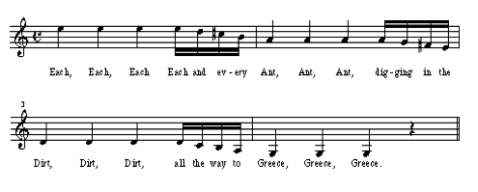

G–D–G (D–A–D and A–E–A)
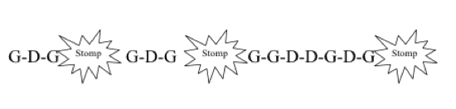

VIOLIN: PRE SHIFTING EXERCISES

Rebecca Henry: “I like Ice Cream”
- Tap over high dot, then in first position, then back to high dot
- Touch your nose!

Pinky Plucks (Paul Rolland’s Shadow Game and violinpractice.com)
- AE pluck (over first position) GD pluck (over high dot)
- Reverse
- Practice on all strings

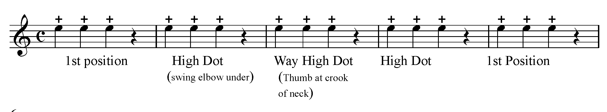
Tap, Swing, and Slide
- Tap fingers on the fingerboard
- Tap and slide up to the high dot and back
- Tap and slide up to the end of the fingerboard and back
- Relaxed thumb

VIOLIN: PREPARING AND ADDING THE BOW

Shadow Shifting
- Without the instrument
- Same directions and opposite
- Different speed

Adding the bow
- Open string slide: slide on the magic X to the third position while playing the open strings on half notes
- Play Twinkle (theme) and slide to the third position and back on opening strings
- Ghosts slides (all fingers on all strings)
- Watch the thumb, make sure the thumb travels with the hand
- Tap the thumb to relax the hand

VIOLIN: FINDING THIRD POSITION
- Play the notes leading up to C, G, D, and A on all strings
- Matching octaves (first with open string) then in third position with harmonic (Rolland)
- Perfect 4th and Perfect 5th exercises (shift during open strings)

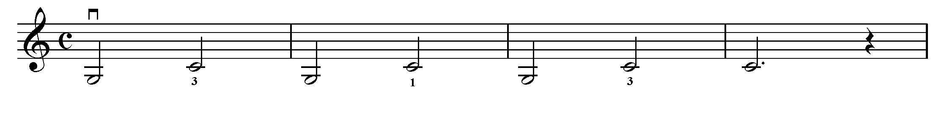
- Practice these exercises on all strings
VIOLIN: PLAYING IN THIRD POSITION
- Practice C and D major scale
- Review songs in third position

- Whistler: Introducing the Positions, Vol. 1

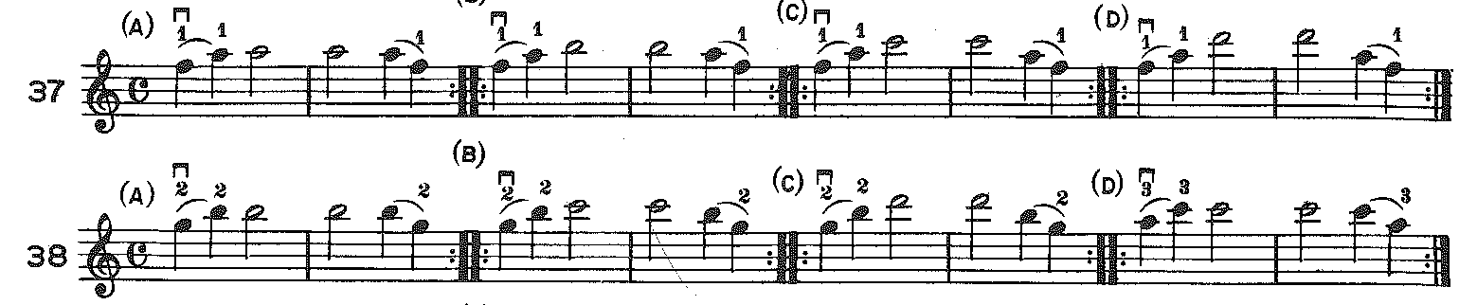

VIOLIN: SHIFTING FROM FIRST THROUGH EIGHTH POSITIONS

Pieces
- Up the Scale with Au Clair de Lune (F major scale)
- Check the high F with F in first position
- Play in first then directly repeat in 8th position (check thumb)
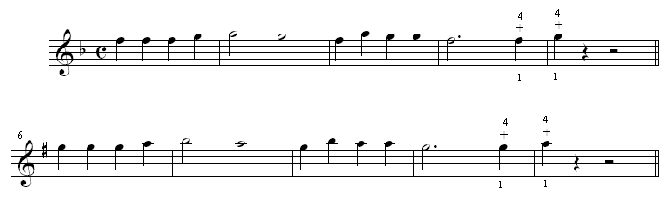

- Walking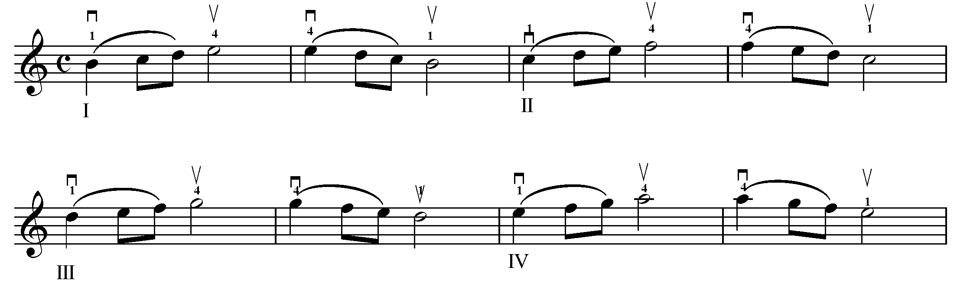

- Ševčík, Op. 8

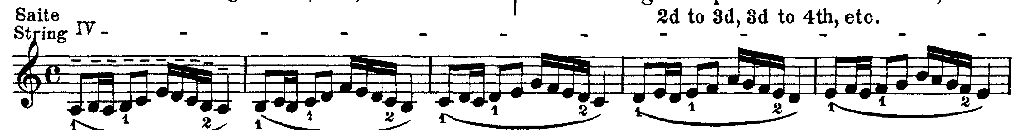

- One finger scale: repeat each note twice. When playing with the third finger, place first and second finger gently on the string (developing good FBB finger patterns)
- Two finger scale

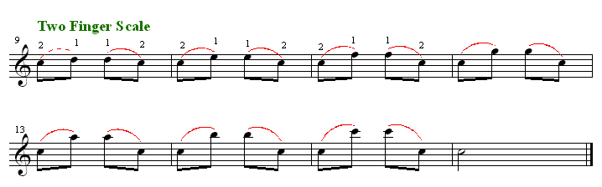

- Carl Flesh Scales: Scales on One String
- Different ways of shifting

DIFFERENT TYPES OF SHIFTS
- Anticipated Shifts (silent shifts)
- Delayed Shifts (expressive shifts)

REFERENCES
Paul Rolland Young Strings in Action
Mimi Zweig Violin Pedagogy
Rebecca Henry www.ViolinPractice.com

